Sprint 2 - Accuracy Design Document

November 16, 2022

Table of Contents

1. Executive Summary 3

1.1 Project Overview 3

1.2 Purpose and Scope of this Specification 3

2. Product/Service Description 3

2.1 Product Context 3

2.2 User Characteristics 3

2.3 Assumptions 3

2.4 Constraints 3

2.5 Dependencies 4

3. Requirements 4

3.1 Functional Requirements 5

3.2 Security 5

3.2.1 Protection 5

3.2.2 Authorization and Authentication 6

3.3 Portability 6

4. Requirements Confirmation/Stakeholder sign-off 6

5. System Design 6

5.1 Algorithm 6

5.2 System Flow 6

5.3 Software 6

5.4 Hardware 6

5.5 Test Plan 7

5.6 Task List/Gantt Chart 7

5.7 Staffing Plan 7

# Executive Summary

## Project Overview

The second project, sprint 2, accuracy design. Where the robot Sphero must successfully run the figure eight course 5 times. A path will be laid out on the floor. Sphero must stay within the path provided. The robot will start and finish in the square provided. Upon finishing, robot will speak ‘I am the winner’ and flash multicolored lights for 5 seconds. Points will be deducted if your robot strays from the path, if it does not go around 5 times, or if it does not finish in the same place, it started.

## Purpose and Scope of this Specification

The goal is for the Sphero robot to follow its path correctly

In scope

This document addresses the processes and requirements to carry out the endurance project:

* Modifications in the process so that the robot complies with its trajectory.

Out of Scope

* Having the robot follow the blue tape exactly, rather than just being within a inch or two from the tape while traveling around the course.

# Product/Service Description

The factors that can affect the product and its requirements are that if for example there is an object in the path of the robot, such as a table, a wall, a chair, a person, etc., because it cannot advance in the desired direction. In addition, if the floor is sloping, it deflects the robot a bit. Also, if the floor is smooth, it will make it slide a little more, but in this case the result will be very similar to what is desired.

## Product Context

The product relates to other products, this means that the robot Sphero is related to other robots, because Sphero is a robot that is controlled remotely. It is self-contained because it contains in itself everything necessary to work. It interfaces with a variety of related systems.

## User Characteristics

Professor Gil Eckert from Monmouth University, master from Kean University and bachelor of science from Stockton State College. He has a lot of knowledge in computer science and software engineering, with a certified network engineer. He did research in simulation, data analysis and manipulation, algorithmic development, and quality control.

## Assumptions

Although we are not experts in programming Sphero, with what Professor Gil taught us, as a group we have the necessary skills to do the programming. After doing sprint 1 (resistance), we feel that we are gaining more experience as we program more. In addition, it is important to have room HH208 available to be sure that the robot makes its way as it should.

## Constraints

Constrain the design options, including

* Connecting to another robot or executing another programming affects the route that you want to give the robot.
* Access, management and security
* System resource constraints: limits on disk space, obstacles in the way of the robot)

## Dependencies

This new product required programming. For the programming, it is required to have the robot Sphero and the space.

# Requirements

## Functional Requirements

| Req# | Requirement | Comments | Priority | Date Rvwd | SME Reviewed / Approved |
| --- | --- | --- | --- | --- | --- |
| ACCUR_01 | Start in the square provided | Points will be deducted | 1 | 11/16 | Approved |
| ACCUR_02 | Robot must stay in the path provided | Points will be deducted | 1 | 11/16 | Approved |
| ACCUR_03 | Robot must complete the course 5 times | Points will be deducted | 1 | 11/16 | Approved |
| ACCUR_04 | Stop in the square provided | Points will be deducted | 1 | 11/16 | Approved |
| ACCUR_05 | Robot will speak “I am the winner” | Points will be deducted | 1 | 11/16 | Approved |
| ACCUR_06 | Robot must flash multicolored lights for 5 seconds | Points will be deducted | 1 | 11/16 | Approved |
|  |  |  |  |  |  |
|  |  |  |  |  |  |
|  |  |  |  |  |  |

## Security

Take care of your privacy, do not tell other people your login information to Sphero or GitHub. Also, take care of your robot, keep it away from dangerous environments.

### Protection

You are the one who controls your app and your programming. After downloading the Sphero app, you can log in in two ways, school and home. When you enter the school part, three different options appear. The first is student, where it asks you for a code to join your class and share your program with them. The second is the teachers, where it allows you to create a class and manage it, this way the professor will be able to know the process that the students have. The third is to skip the sign in part and start programming immediately, these users have the possibility to sign in whenever they want. On the other hand, there is a home, where you can enter through your email or also sign in with apple.

### Authorization and Authentication

Specify the Authorization and Authentication factors. Consider using standard tools such as Pub Cookie.

## Portability

Portability is the ability of software to be transferred from one machine or system to another. In this case, after programming from the cell phone or the computer, we need to pass the information to the Sphero robot so that this can work. For example,

* Use of a proven portable language;
* Use of a particular operating system. Sphero and GitHub;
* The need for environment-independence - the product must operate the same regardless of operating systems, networks, development or production environments.

# Requirements Confirmation/Stakeholder sign-off

Include documentation of the approval or confirmation of the requirements here. For example:

|  |  |  |
| --- | --- | --- |
| Meeting Date | Attendees (name and role) | Comments |
| 11/14/22 | Michael, Sophia | Confirmed all except programming |
| 11/16/22 | Michael, Sophia | Confirmed all |

# System Design

This section will provide all details concerning the technical design, staffing, coding, and testing the system

## Algorithm

* Set the robot to start in the square
* Robot will follow the blue tape in the figure eight path
* Set robot to complete the figure eight path 5 times while touching the blue tape at all times
* Set robot to stop on the square when the course is completed
* Robot will speak “I am the winner”
* Set robot to flash multicolored lights for 5 seconds

## System Flow

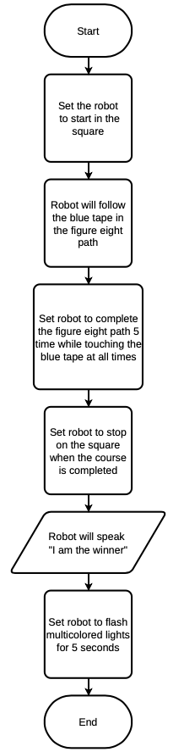

## Software

The software used to develop and deploy this application is the block code on the Sphero app or website.

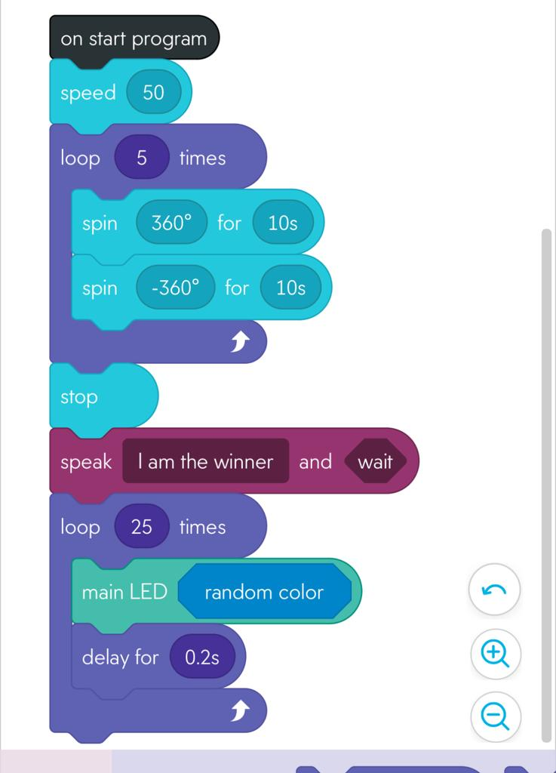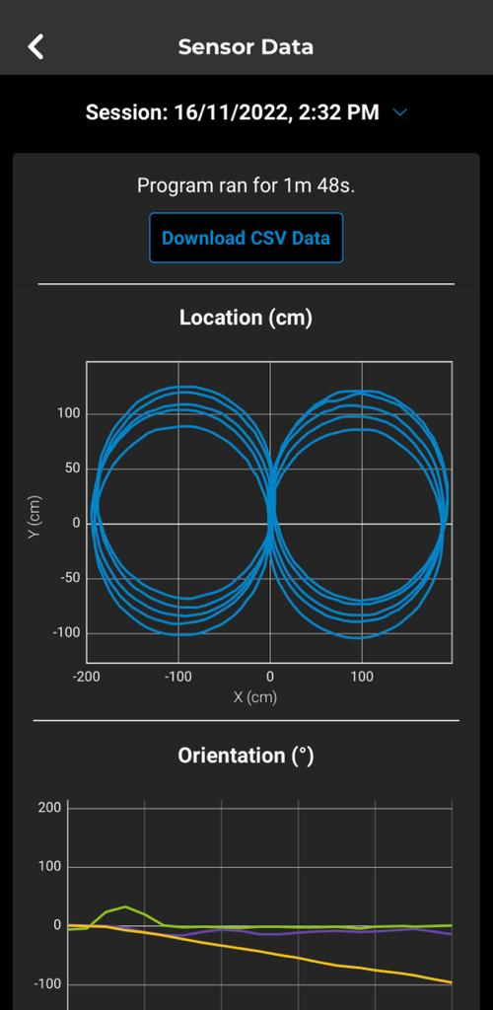

## Hardware

The hardware platforms that were used to develop, test and demonstrate this application were macOS, Microsoft Windows, and IOS.

## Test Plan

| **Reason for Test Case** | **Test Date** | **Expected Output** | **Observed Output** | **Staff Name** | **Pass/Fail** |
| --- | --- | --- | --- | --- | --- |
| To see if robot goes in circle | 11/16 | Follow the first blue tape circle | Made a smaller circle than the tape | Michael, Sophia | Fail |
| To get around the figure eight once | 11/16 | See if the eight figure works | Made it around the eight figures | Michael, Sophia | Pass |
| To get around the figure eight, five times | 11/16 | See if the eight figure works five times | Made it around the eight figures five times | Michael, Sophia | Pass |
| Light did not turn on in last run | 11/16 | Lights turn on at the end | Light did not turn on | Michael, Sophia | Fail |
| Light did not turn on in last run | 11/16 | Lights turn on at the end | Light turned on at the end | Michael, Sophia | Pass |
| Robot went a little of course after 3rd lap | 11/16 | Stay on course more accurately | Went of course after 3rd lap | Michael, Sophia | Fail |
| Robot went a little of course after 3rd lap | 11/16 | Stay on course more accurately | Sayed on course better | Michael, Sophia | Pass |
|  |  |  |  |  |  |

## Task List/Gantt Chart

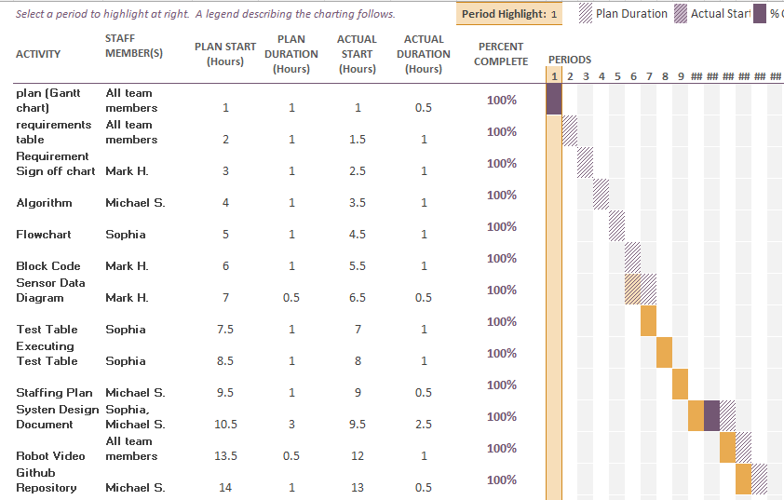

## Staffing Plan

| Name | Role | Responsibility |
| --- | --- | --- |
| Sophia | SDD creator/editor | Create and edit the System Design Document |
| Mark | Programmer | Create the block cod and test it |
| Michael | GitHub Owner | Control the GitHub repository |